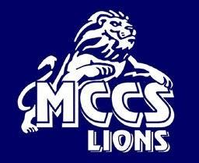
Millers Creek Christian School
Golf Tournament Saturday, May 13, 2023
Brushy Mountain Golf Club

Sponsorship Opportunities

*Sponsorship LIONS*

Cash

or
Check # Logo
PLATINUM LION– Sponsorship donation $1,001.00 and over

Platinum Paw will receive largest logo on T-shirt, Hole Sponsorship, and our person team entry. Additional lunch, afternoon snack, or golf car sponsorship signage of your choice – only available to 3 sponsors.

GOLD LION – Sponsorship donation of $501.00 - $1,000.00
Gold Lion will receive logo on T-shirt and large hole sponsor signage.

SILVER LION– Sponsorship donation of $251.00 - $500.00 Silver Lion will receive logo on T-shirt and small sponsor signage on tee.

BRONZE LION – Sponsorship donation under $250.00 Bronze Lion will receive name on T-shirt.

.

NEED MORE INFORMATION?
Email us at...golftournament@mccslions.org
Or call (336) 838-2517
If you would like to include a logo to be used on advertising materials, please email logo to golftournament@mccslions.org

